CN Lab 3
Q3.1.
Retrieved the web pages using http filter.
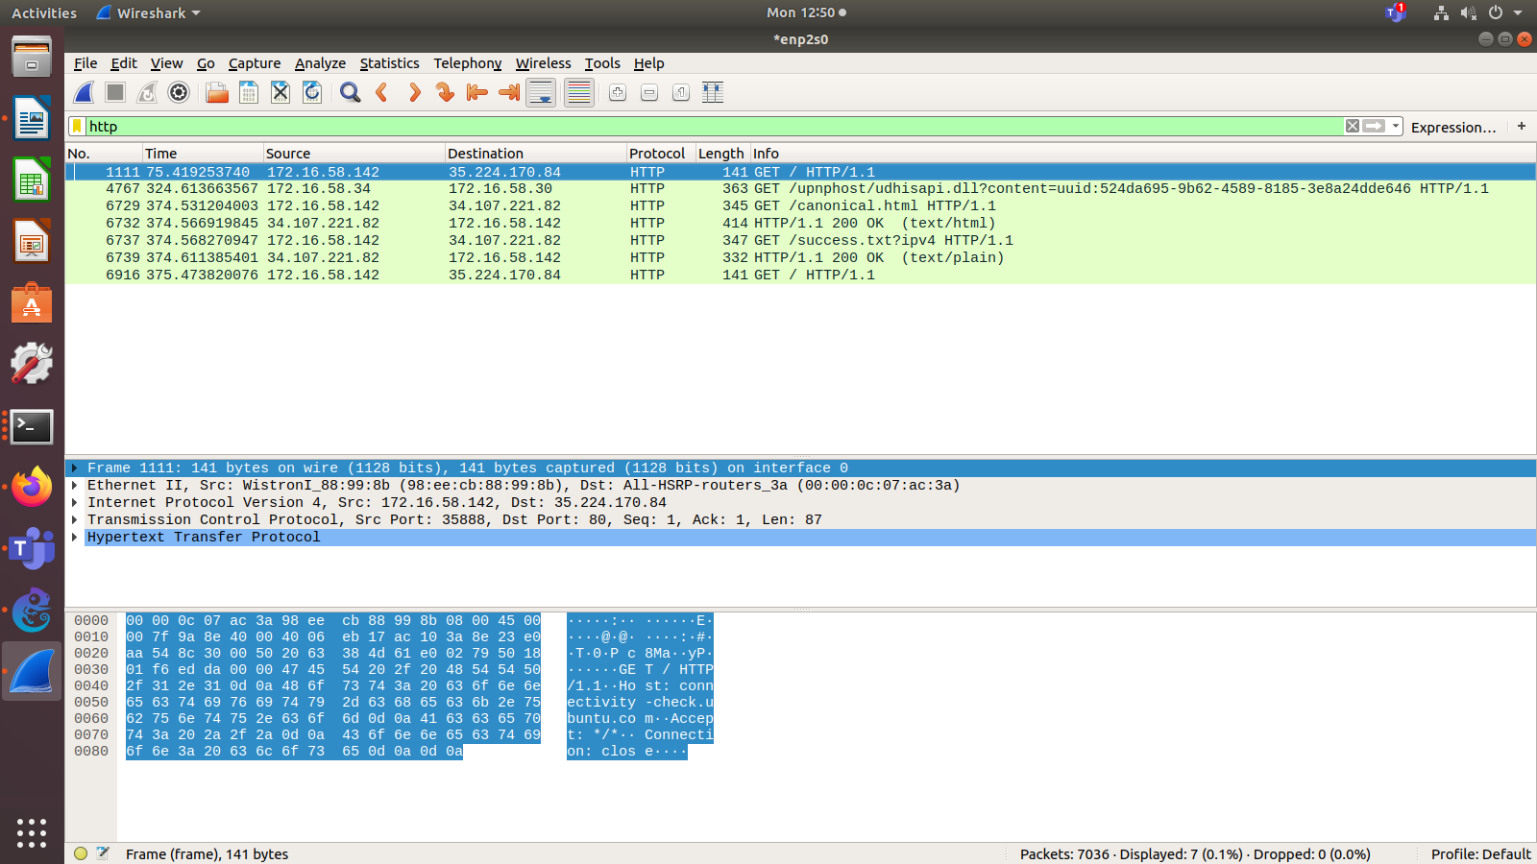
First 2 GET and responses give us the home page and the next 2 sets of GET and response are the 2 pages accessed in the website:
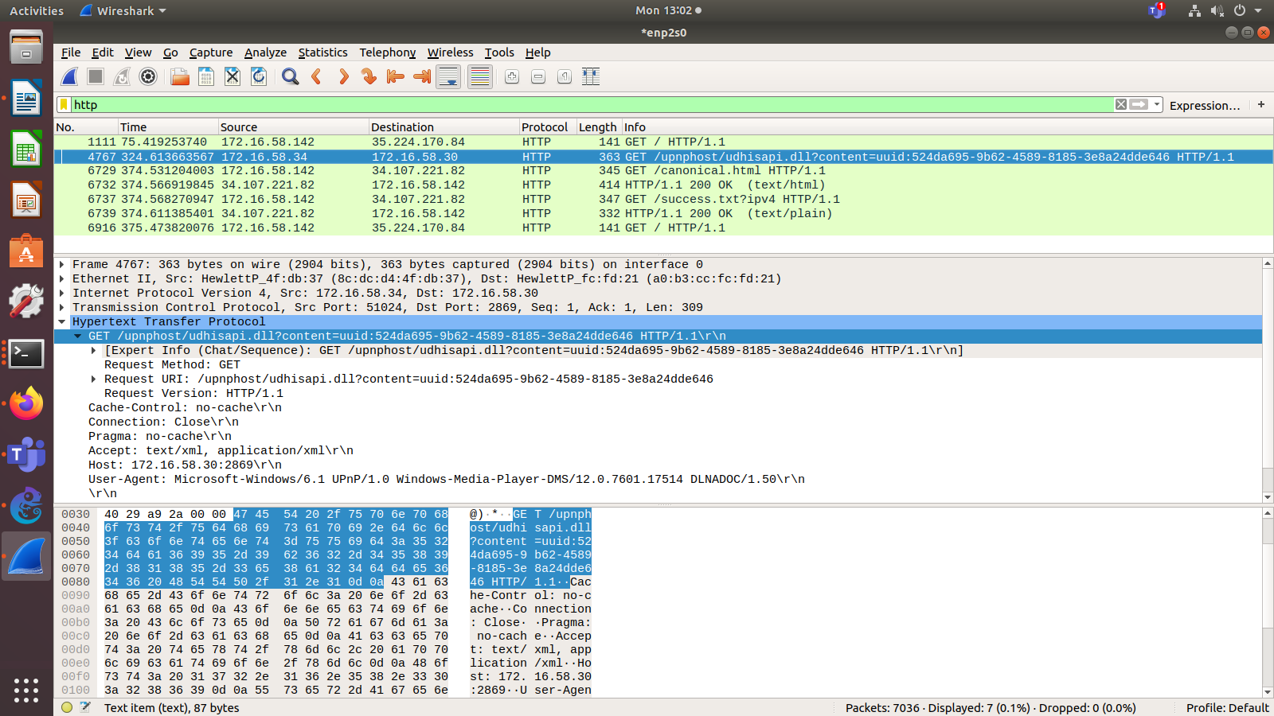

Http Headers:

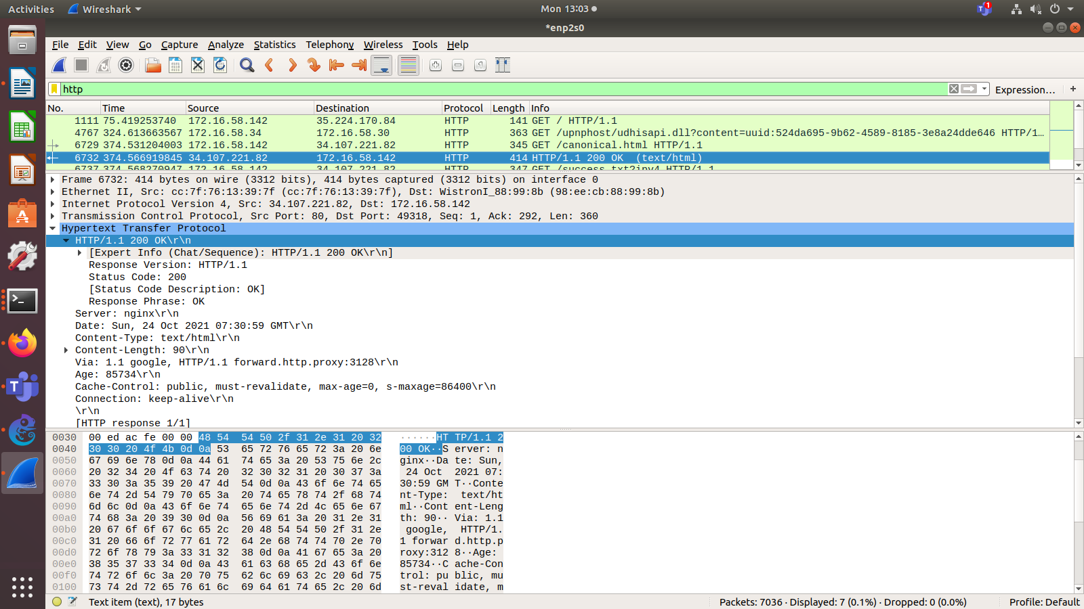
Q3.2.

Accessing the FTP using the terminal:
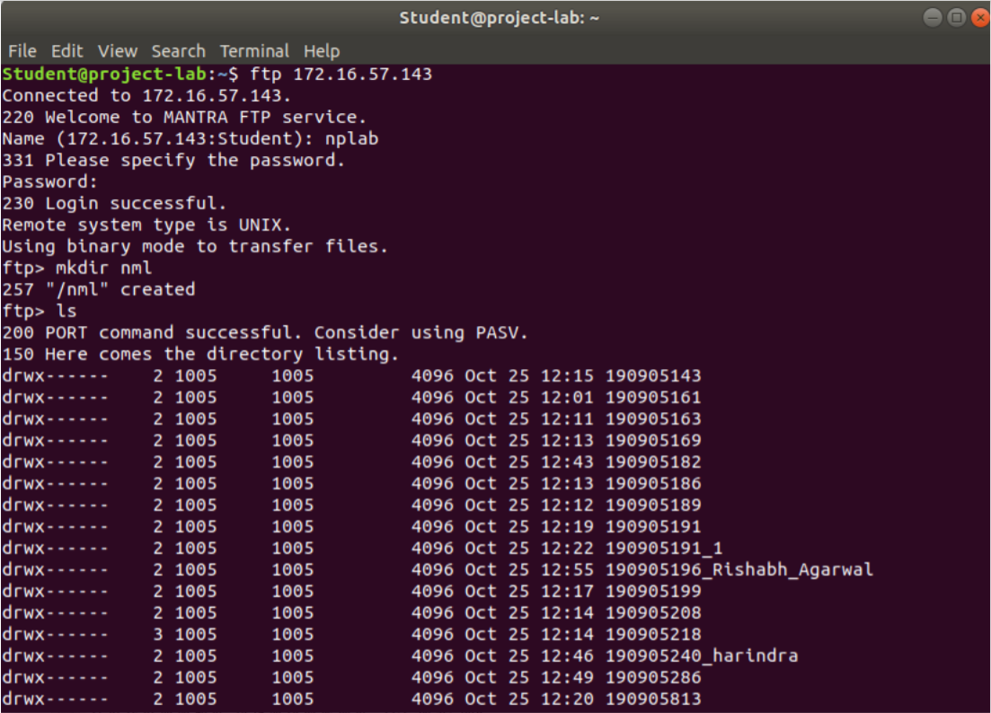
Initial messages and responses. We can see that the password is sent as plaintext which shows us that FTP is not a secure transfer protocol. SYST request is sent when ls command is executed: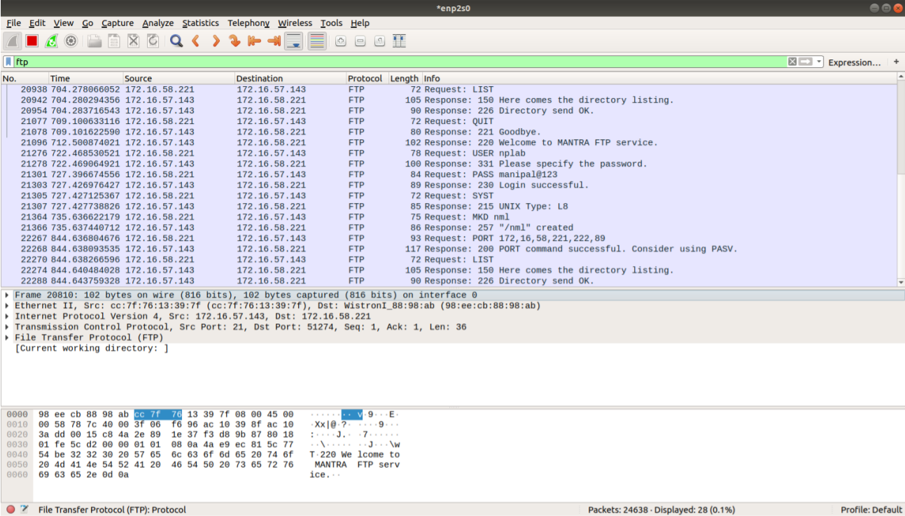

Q 3.3.

DNS uses the UDP protocol in the transport layer. The source port for the UDP protocol is 53 and the destination port is 51601. The request is sent from source address 172.16.19.203 to destination address 172.16.58.221.
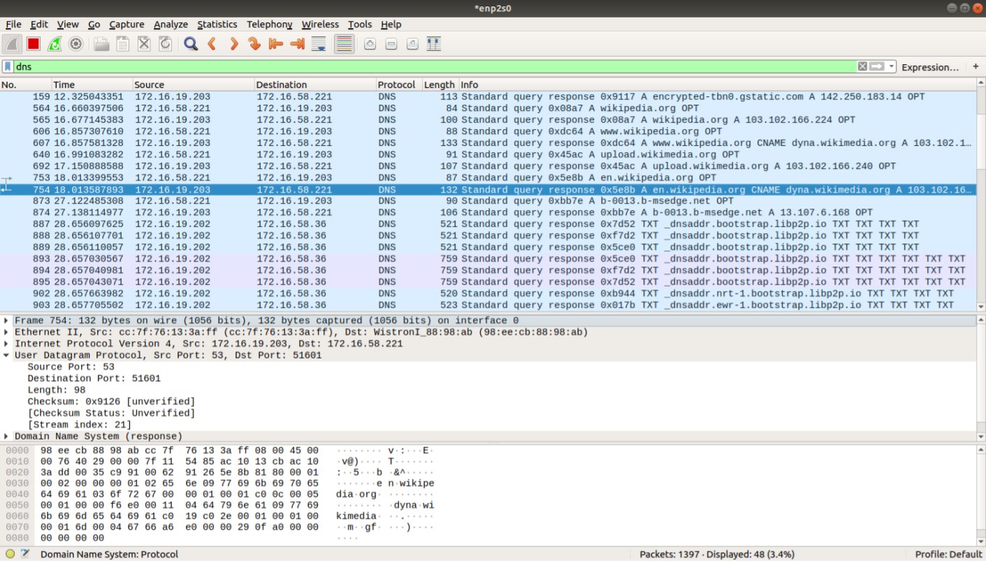

Q4.1.
Network configuration desogned as shown below.
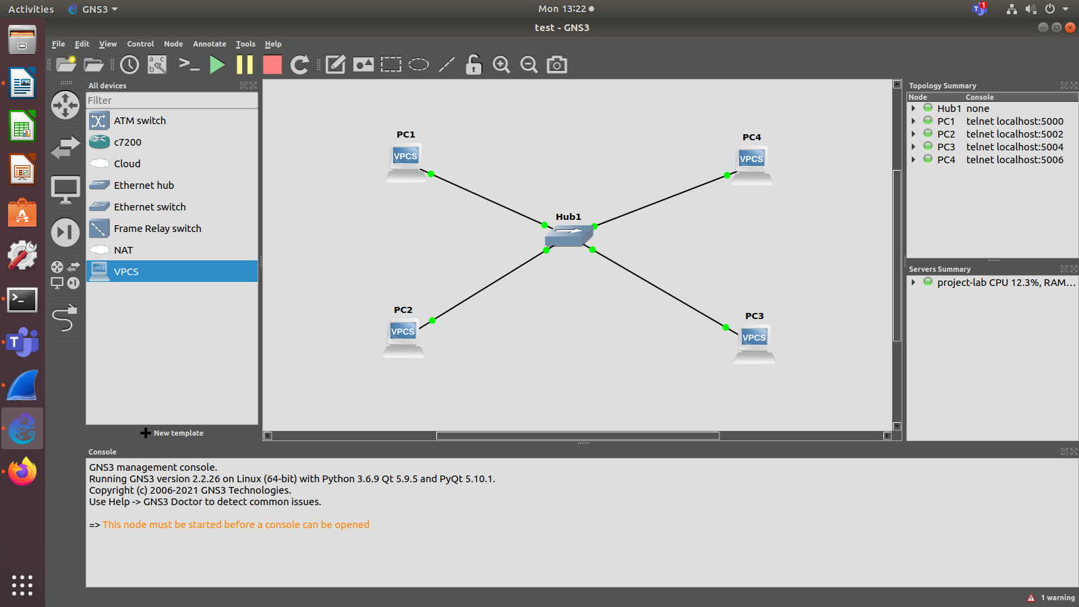

Started Wireshark on PC1-Hub1 link with a capture filter set to the IP address ofPC2.
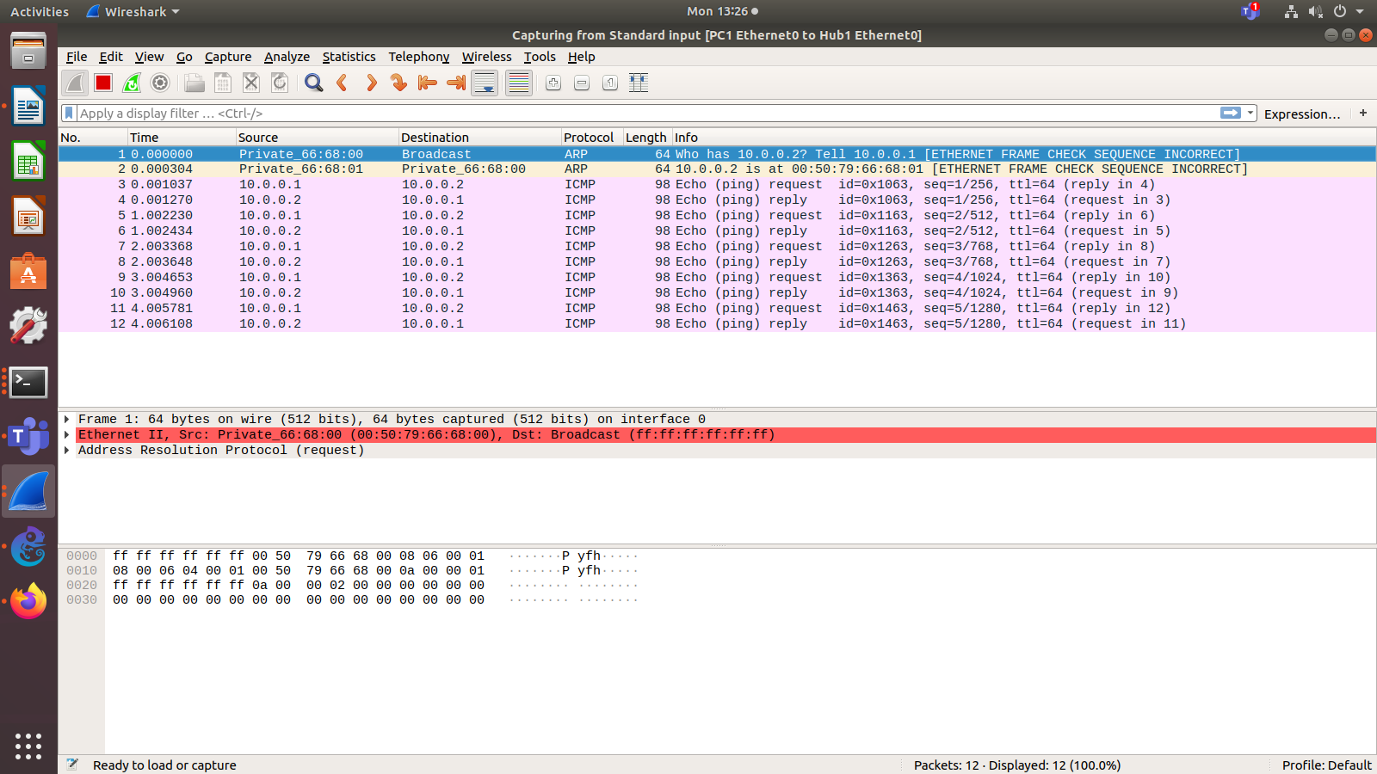

ARP packets in the Wireshark window with the MAC addresses in the Ethernet headers of the captured packets.
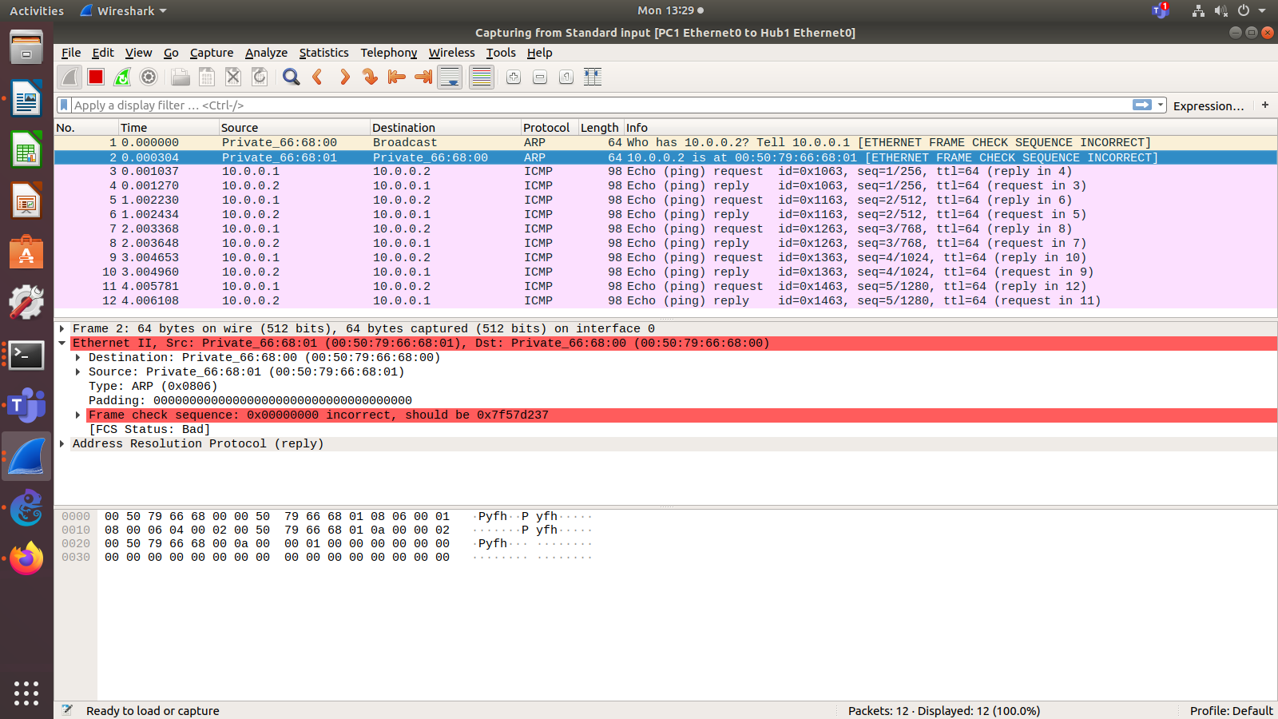
Destination MAC address of the ARP Request packets: 00:50:79:66:68:00
Type field in the ethernet headers is ARP(0x0860)

ARP packets for PC1
